PROJECT LIBERTY ELECTRONICS
INSTALLATION GUIDE
Software requirement:
- XAMPP with PHP ver.8.0.x or newer install on a PC or laptop.
- Web browser such as Chrome, Edge, Firefox,…(Highly recommend Chrome)
Step 1. Install the database:
First, if there is already a database with the name ‘electronic’ in phpMyAdmin, please drop it before proceeding.
Second,create the database using ‘Import’ in phpMyAdmin to import file ‘electronic.sql’ .
Step 2. Install the website source code:
Download or copy source code into the ‘htdocs’ folder where XAMPP is installed.
Example:
- C:\XAMPP\htdocs\electronic
- C:\XAMPP\htdocs\c2108l\electronic
With all Domain, navigation will be smooth.

Step 3. Check the connection:
The connection to the database was defined in the file: mvc\core\DB.php. If your server has different configuration (host name, username, password…), you should check this file and change the information accordingly.

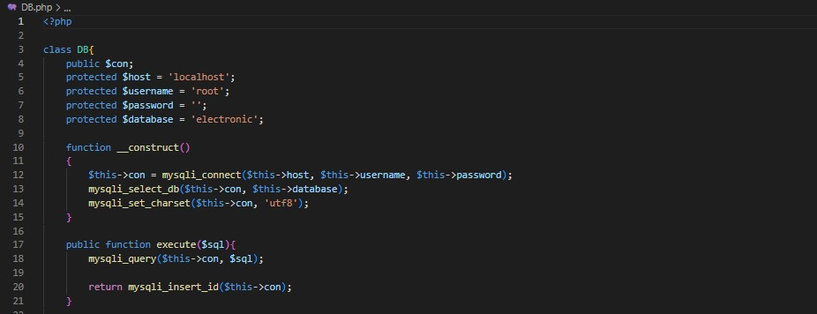

Step 4. Access application:
To access the homepage, please open your browser and type “<yourDomainName>/electronic” and press enter (for example: localhost/electronic if you install the application on your local computer).
To access the administrative tools, please open your browser and type “<yourDomainName>/ electronic/admin” and press enter (for example: localhost/electronic/admin if you install the application on your local computer).
Note: when using Chrome, if the site fails to load the css file, please press ctrl + f5 to reload the page.
To login the admin page, please use the following information:
Email: admin@gmail.com
Password: admin
This is the root account which has the highest authority. You may use it to create other account or change the password if you want but remember to keep this account safe!
For technical support please contact us: vinh.nq.1932@aptechlearning.edu.vn
=================================END INSTALLATION GUIDE====================================

